AUGUST – SEPTEMBER 2015
Theme: Working Together
To begin each recess period, have students walk/run around the track/field. Begin the year with 3 min. and work your way up to five for all and then let those who would like, go longer and rack up laps for the class. Have a student helper keep a tally of laps per class. (10 students ran 2 laps, 10 students did one lap in the allotted time for a total of 30 laps). 7 laps = a mile on bus lot, 4 and a half laps on parking deck field = a mile (but for simplicity round to 5 laps). Pick a destination and chart your way from Charlotte to _______. When your class makes it, let Mrs. Sluder know so your name can be added to the traveling the U.S.A. wall in the gym! Class recess equipment will also be awarded!
Cooperation Games (expectations- take turns and share, work with and help others, encourage others, say nice things like “great catch”, give compliments like “you’re a fast runner”).
Hula Hoop Pass – In a circle, students hold hands and pass a hula hoop around the circle. Each student will take a turn to get through the hoop and send it on to the next person without letting go of hands. Options: Have more hula hoops going around/have two cirlces challenge to see who can get the hoop around the fastest.
Pile to Pile- Students hold hands in groups of 6 or 7 (try to make even #’s on teams) in a straight line standing side by side. All hoops start in a pile at one end of the line and they must move one hoop at a time down to the other end of the line.
Through the black hole- (on grass) in partners with one hula hoop. One student rolls the hoop and the other tries to run along beside and slip through it before it hits the ground.
****
One minute madness- (playground ball) groups of three form triangles (10 feet apart). On a signal, students try to exchange the ball to all three partners in the following order: two hand underhand pass, chest pass, chest bounce pass, lateral pass, and overhead pass. Group will sit down when challenges are complete trying to beat 1 min. This can be modified for students to count how many of a certain pass they can do in 1 min.
3 Pass Game- games of 2 vs 2 or 3 vs 3. (grades 3 – 5 with yellow squishy balls) Offensive team members try to get three catches in a row to score a point. The player that has the ball may only move two steps and then must use a pivot only. The defense tries to intercept and get in the way so the pass cannot be completed. If the offense drops the ball, it immediately goes to the other team. A ball may not be hit out of someone’s hands. Variation: Add 2 hula hoops as goals. Once the 3 catches have been made then the offense tries to shoot into either hoop. More than 3 passes can be used if needed.
Mousetrap (K-2)
Half of the children form a circle with hands joined and face the center. This is the trap. The other children are on the outside of the circle. These are the mice. Three signals are given for the game. These can be word cues or other signals. On the first signal, the mice skip around, outside the circle, playing happily. On the second signal, the trap is opened. (The circle players raise their joined hands to form arches.) The mice run in and out of the trap. On the third signal, the trap snaps shut. (The arms come down). All mice caught inside join the circle. The game is repeated until all or most of the mice are caught. The players then exchange places, and the game begins anew.
Shake the Snake- (cloth ropes) 1 rope for each two people. The runner holds the rope lightly between thumb and index finger. The chaser runs after the runner with the rope and tries to step on the rope. When successful the chaser becomes the runner with the rope.
Bean Bag Freeze- all students walk around with a bean bag on their head trying to balance it and keep it on. If someone loses their bag they must freeze in place. Anyone can help them by picking it up without losing their bag to replace the bag of the frozen person.
One Against Three (Dodging, Tagging)- 4 people per game Equipment: None
Appoint one “IT” for each group of 4 players. Players 1, 2 and 3 must join hands to form a circle. “IT” calls out the name of the player they want to tag and begin chasing him/her around the circle. The other 2 players should protect the person being chased by shifting from right to left. Try to avoid dropping hands and falling. When “IT” successfully tags the person, they trade places and a new tagger is chosen.
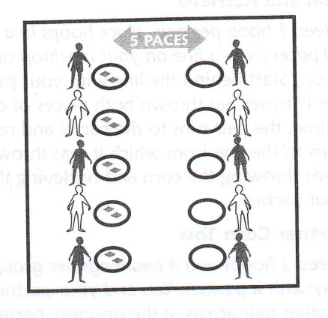
Corn Toss- groups of two, one hula hoop per student,
2 bean bags per student
Students take turns underhand tossing their bean
bags into the opposite hoop (2 points in, 1 point on hoop)
Variation: 2 vs 2 (use 8 bean bags)

Four Square - How To Play (3rd – 4th – 5th)
- Each player stands at a corner of one of the four squares.
- To start the game, the player at the King position (#1) serves the ball by bouncing it in their square once and then hitting it towards one of the other squares. The receiving player then hits the ball to any other player in one of the other squares.
- The ball must bounce in another player's square, and they must hit it to another player before it bounces a second time.
- Have students use an underhand motion, striking the ball with two hands (beginner).
- A player may hit the ball before it bounces, if they choose to do so.
- If a player hits the ball so that it misses another player's square, or fails to hit the ball before the second bounce after it has landed in their square, they are "out".
- When a player is out, the other players move up to take their place, and that player moves to the last square, or to the end of the line, if there are more than four players. (King, Queen, Jack, Joker or #1, #2, #3 and #4).
- The object of the game is to move up to and hold the server's position.

Variations of four square
- If you have eight or more players, you can have two players for each square. Each time a player hits the ball to another square, they will jump out of the court, and their partner will jump in. The two players will keep trading places each time the ball is hit towards their square.
- When players bounce the ball, they must also call out the name of a country, a state an animal, a movie star, or whatever the category may be. A player is out if they repeat something that's already been said.
- Around the World- King calls out Around the World and picks a direction for the ball to travel, he/she can call out left/right to change the direction.
- Use paddles to strike a ball.
- 2nd graders- have them start with “catch 4 square”. After the ball bounces in their square, they can catch it then drop the ball and strike it to the next person.
- Pre-k and 1st grade: have them use scoops (plastic milk jugs) and a bean bag to make it a tossing game.
Group Relays- Lines of 5 or more, use yellow squishy balls
*Pass over- Start with a ball in the hands of the first in line, then they pass it overhead to the person behind them and so on to the last player who runs up to the front and hands the ball over their head.
*Straddle ball- ball begins with first person, all students stand with feet wide (straddle) and try to get the ball to roll all the way to the last person who runs the ball back to the front.
*Over/Under- ball begins at front and is passed in a pattern of overhead and then under between legs as it moves down the team line. Last person runs the ball to become the front of the line and starts the relay again.
*Pass and Duck- one player with a ball stands facing their team, about 10 feet away. With the team in their straight line, the player with the ball passes it to the first in line who passes it back and ducks down. The passer sends the ball to the second player who passes it back and then ducks. As the last player in line gets the pass, she/he runs to be the new lead passer out facing their line and everyone stands back up.
Hopscotch- Have students go through the pattern (1 foot, 2 feet). Work on alternating which one foot lands. Have them try sideways, backwards traveling. To add challenge, pick categories such as girls names, fruits, favorite tv shows, or sports for each hop/jump they must name an item.
The game- toss a beanbag/rock into the first square. Travel with alternating hops/jumps over the marker and down to the end of the pattern. Player must turn around and hops back through the court, moving through the squares in reverse order and stopping to pick up her marker on the way back. Game continues with the next person in line taking their turn. When students take their second turn they try and toss the bean bag to one of the next squares.
Adapt rules based on skill levels to provide maximum success/challenge. If while hopping through the court in either direction, the player steps on a line, misses a square, or loses her balance, her turn ends. The player starts on her next turn where the player last left off. The first player to complete one course for every numbered square on the court wins the game.
Long Jump Roping- (in order simple to complex)
Jump the stick- 2 students hold the rope so that the middle is a few inches off the ground. The rope stays still while the jumper goes side to side over the rope or jumps front to back over the rope.
High Water- same as jump the stick but pick the rope up higher
Helicopter- one person with the rope spins around making the rope slide along the ground around them. Other students try to jump the rope as it passes so as to not get touched with the rope.
Pendulum Jump- rope holders tick tock the rope making a pendulum motion. Student jumps straight up to clear the moving rope.
Regular jumping- jumper in the middle, students start rope with the pendulum motion while counting to three. On three the turners send the rope over the jumpers head and then the jumper begins to jump.
Chants- Candy, Candy in the dish: How many pieces do you wish? One, Two, Three (and so on).
Teddy Bear: Teddy Bear, Teddy Bear- Turn around, touch the ground, tie your shoe, jump turn too, go upstairs, turn out the lights, say good night (exit).
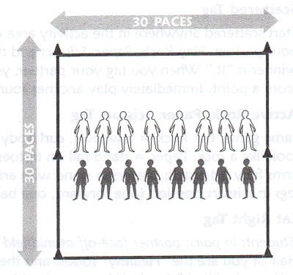
Run through- turners start turning the rope **Front door- when the rope hits the ground it is telling the student to go (rope comes down toward the bridge of the jumpers nose)** and students try to run through without being touched by the rope, no jumps.
Jump Stunts- students are able to add trick jumps inside the long rope.
Hot Pepper- Turners progressively make the rope go faster (per student request).
The Rising Bridge- One turner will gradually step backward causing the middle of the rope to rise higher.
Running In- The jumper starts outside the turning rope and decides when to run in and start jumping.
(Practice front door- rope direction coming down over the bridge of nose and back door- rope direction coming up under the nose of the jumper for them to run in as soon as it clears their nose and is going upward. Note: as students get more advanced for Double Dutch the ropes are moving front door and back door at the same time.
Egg Beater- You need two long ropes and four turners. The ropes create a “+” shape. The ropes are turned in unison.
Double Dutch- (3 = 5) The turners work together to have their right arm turning counterclockwise while their left arm turns clockwise. An even rhythm is established so that when one rope hits the ground (6 o’clock) the other rope is up (12 o’clock). **Should practice just the turning part first**
When a jumper is trying to run in he/she will notice that the “door” is open when one rope is up (noon) and the other rope is on the ground (6 o’clock) As they get in they will immediately jump a rope that will be coming under them.
Partner Challenges-
Rock, Paper, Scissors Tag - students will face each other at a center line. Behind each of them is another line about 30 feet away. Students will play rock, paper, scissors with the winner becoming “ it” to move forward to tag the loser who will turn and go straight behind them trying to get to the safe line before they are tagged.
Odd-Even Tag is played with the same formation as Rock, Paper, Scissors tag, except students will show a number of fingers to add up a total. If it is odd one player wins and is the tagger the even person flees. If the numbers on their fingers add up to even, then the other player is it to chase the odd number player (dice may also be used).
Partner Duck, Duck Goose- played with same formation as the two games above, but now you take turns tapping your partner on the shoulder saying duck, duck, duck, goose. The person who says goose will run straight back to the line behind them.
Jumping Bean Bag- groups of three. One student holds a large playground ball with a bean bag on top of it. When the person with the ball drops it from shoulder height, the other two are designated as one trying to catch the bean bag and one trying to get the ball. Points are earned by the team when both the ball and bean bag are caught.
Team Juggle- groups of 5 or more, bean bag or ball. Students will create a star pattern to throw in order from the 1st player up to the 5th. (thus cannot pass to someone beside you or someone who has already caught the ball.) When the order has been determined students will practice with one ball tossing it in order. When successful, the teacher will add a second ball to the group juggle. Make sure the next person is ready before the toss. Count successful catches in a row for a team score.
Cars and Driver- groups of two with the person in back putting their hands on the front person’s shoulders. The person in back is the driver taking their partner through the area.
*forward, backward, circle around a cone, figure eight around two cones, slow, medium, fast, race track.
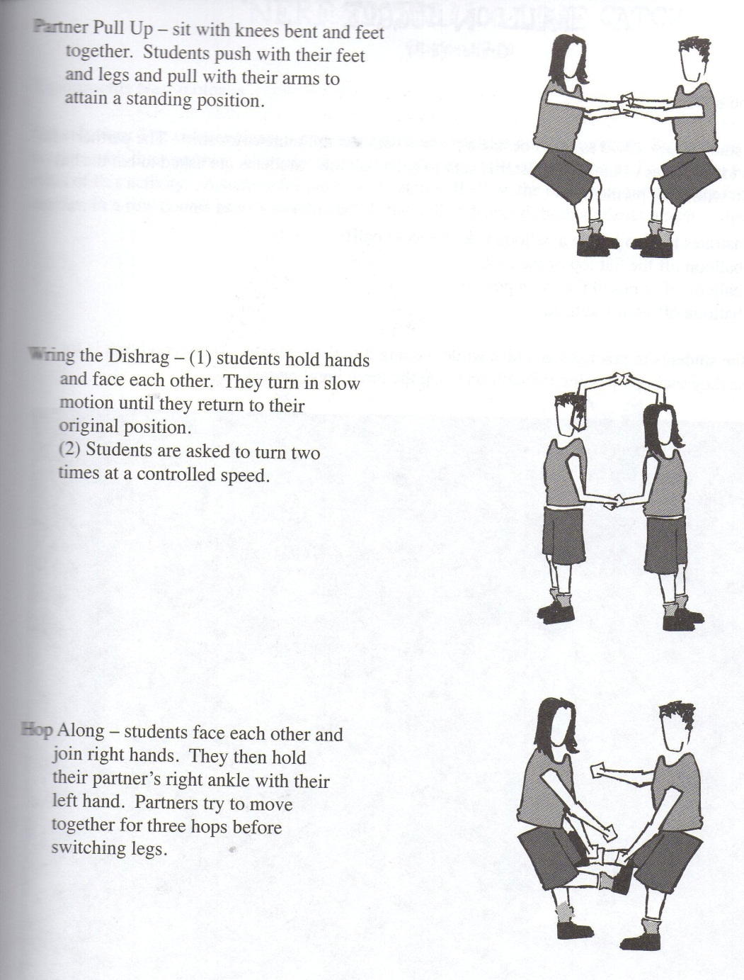

S.L.A.P- Face a partner with a cone (scoop) in between. Using quick reactions, the students will respond to teacher direction and the first to complete the action or actions knocks the cone over.
*clap hands twice * 2 jumping jacks *360 spin *2 push-ups *put two tasks together
*allow students to come up with next challenge or challenges to complete
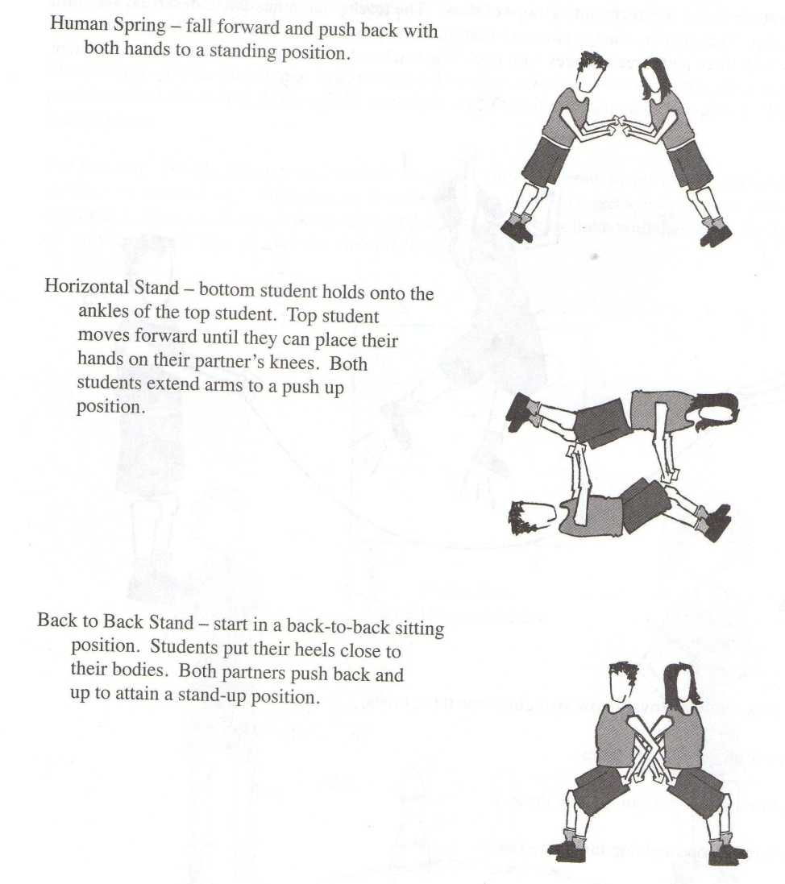

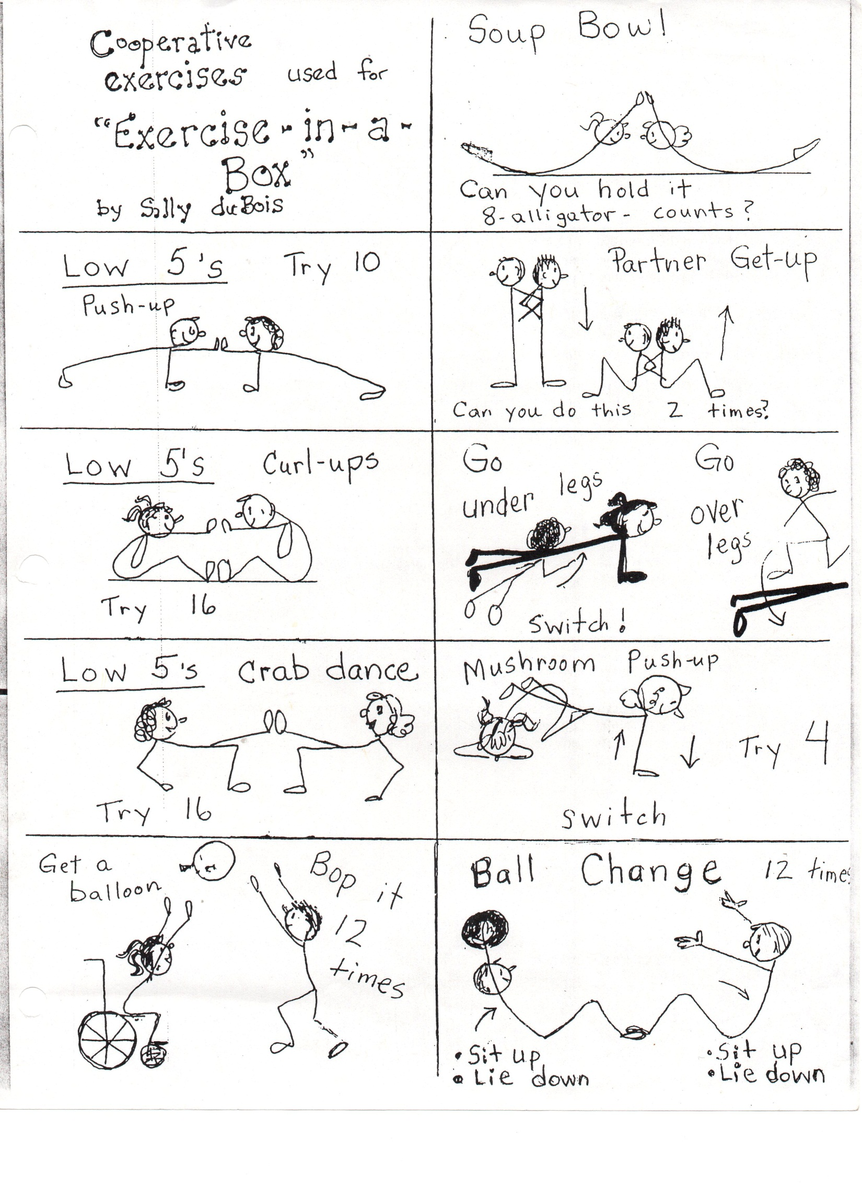
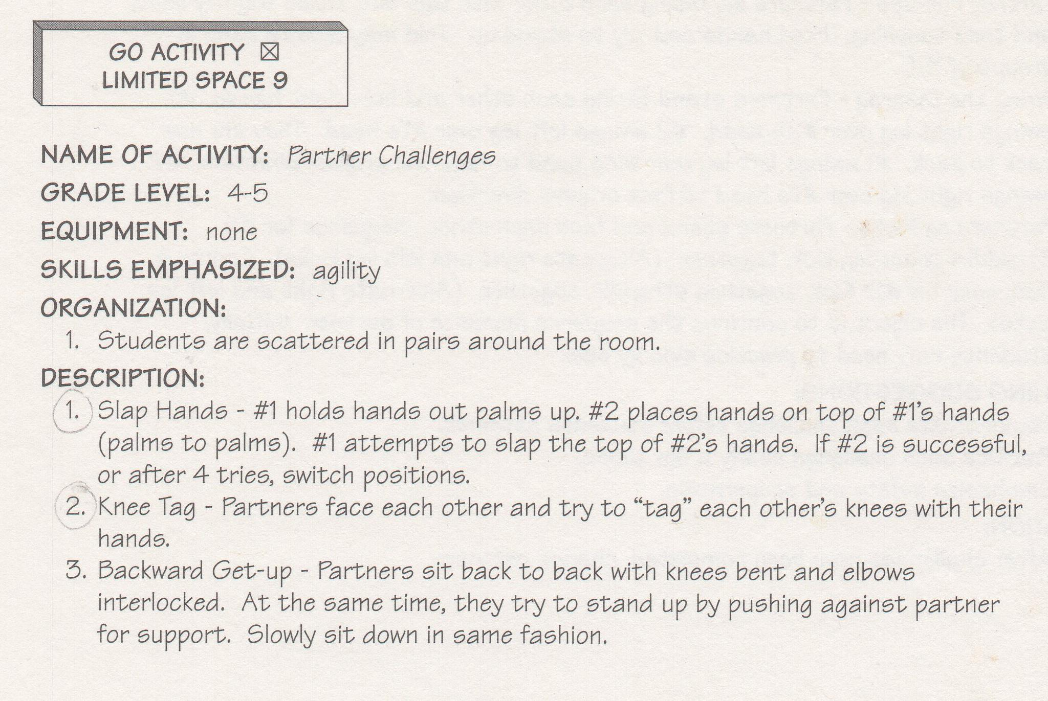
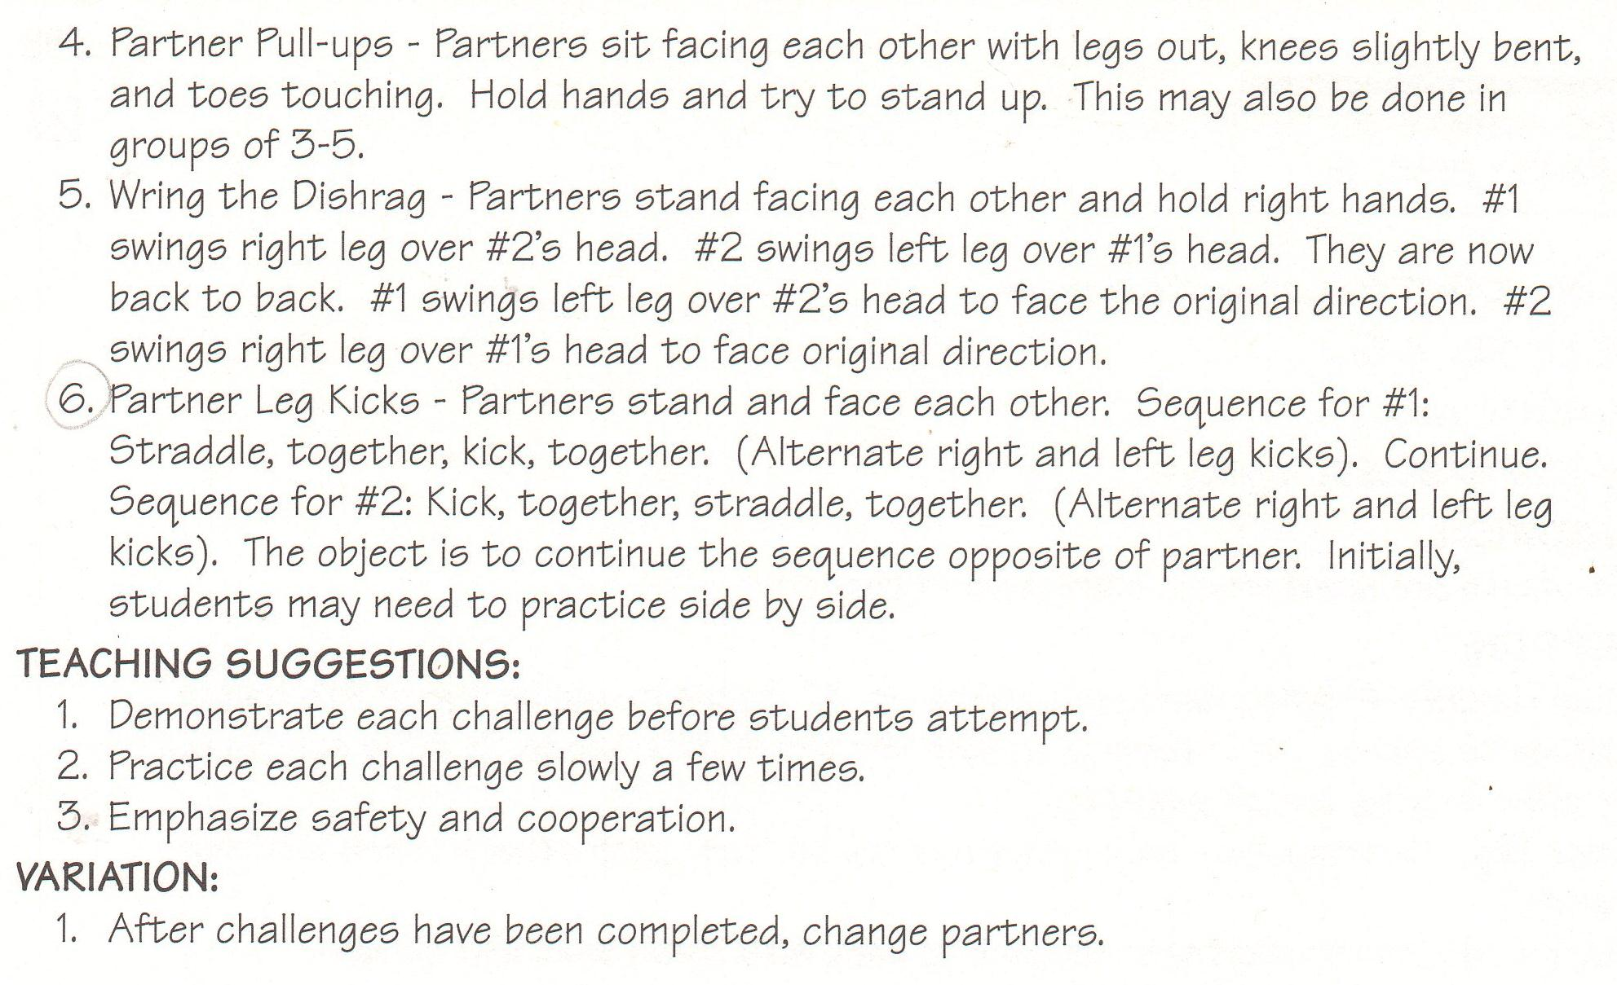
Punt, Pass and Kick (3 – 5 challenge) younger kids may practice throwing/catching
Using the kicking tees and footballs have students practice punting, passing and kicking to one another.
Object of competition is to have the longest total distance, adding up the best punt, pass and kick. It is important for these elements to be performed in a straight ahead controlled manner to get the best score possible.

OCTOBER – NOVEMBER 2015
Themes: Speed Under Control/Offense and Defense
Jump Rope Initiative- As students practice the jump rope skills below, have them write their name and your name on an index card and write down the tricks that they can do for at least 10 jumps in a row. When they have at least 10 skills complete, you sign their card and turn it into my mailbox!
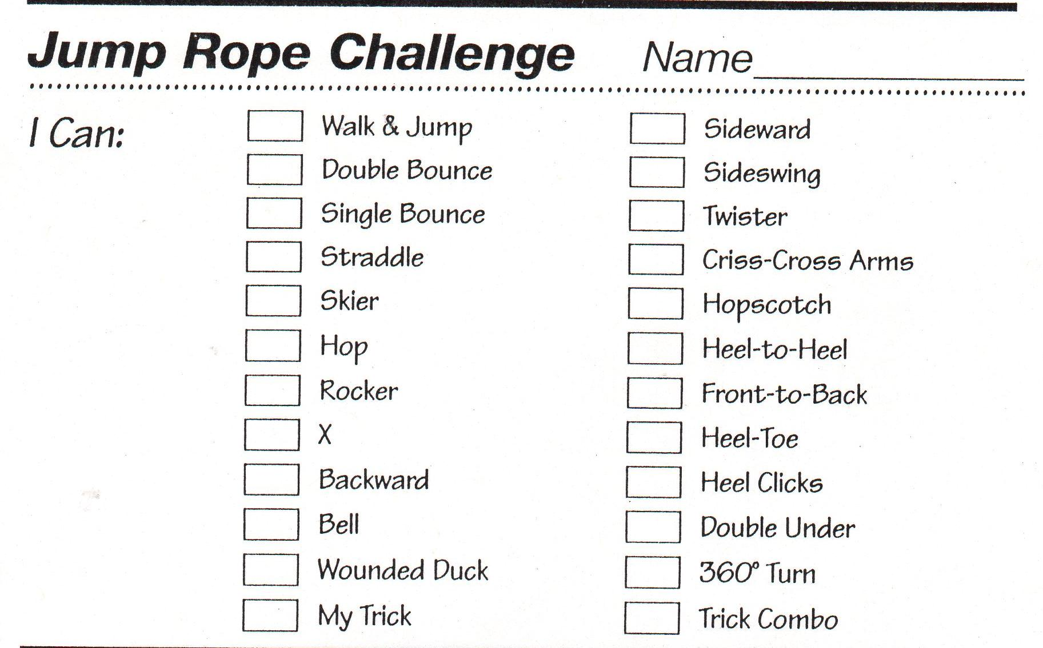
Hula Hoop contest- request hula hoops and as the students practice, have them write their name and your name on an index card and write down the tricks that they can do for 8 – 10 seconds. When they have at least 5 skills complete, you sign their card and turn it into my mailbox!
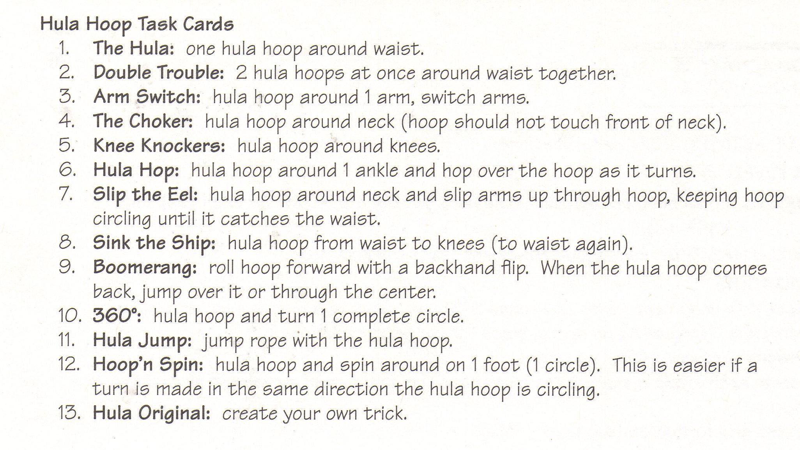
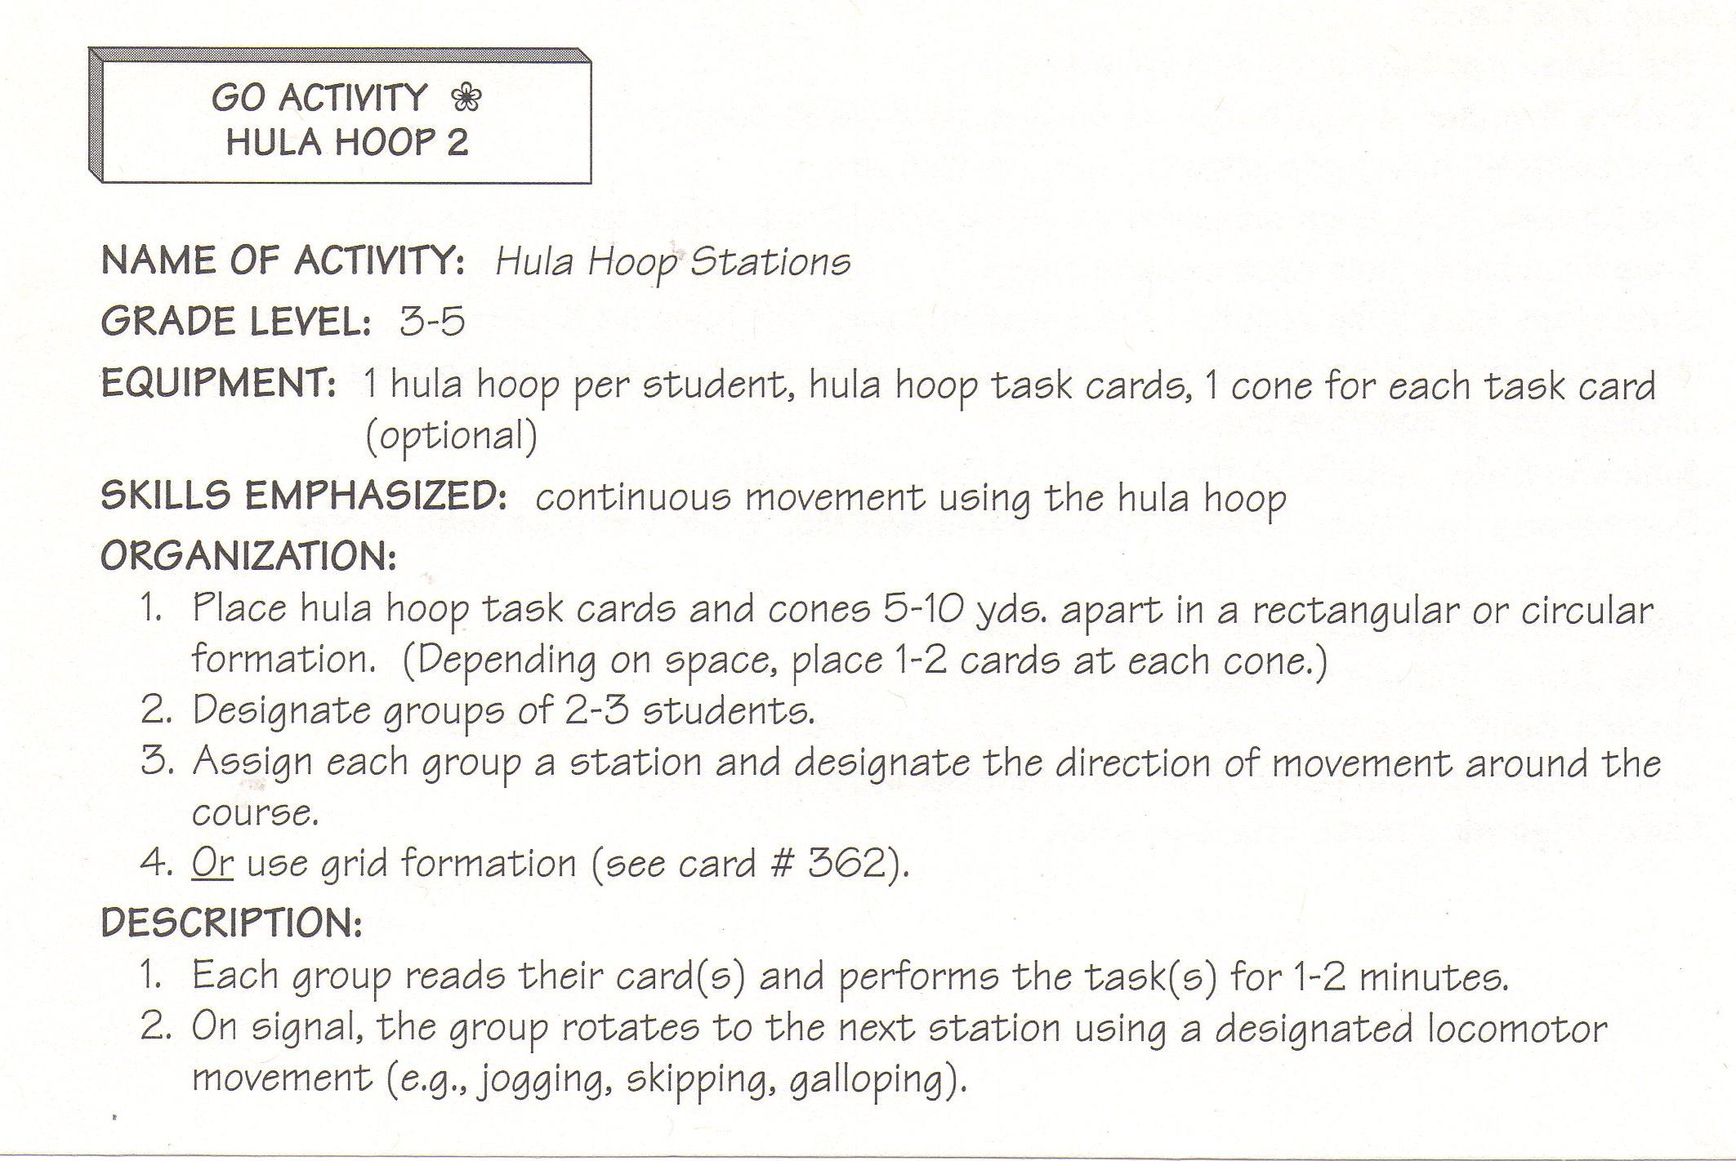

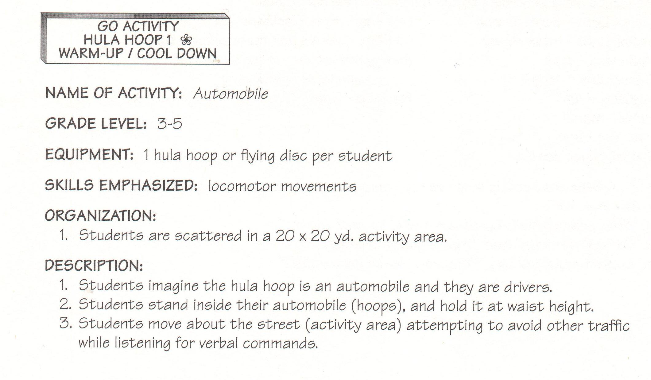
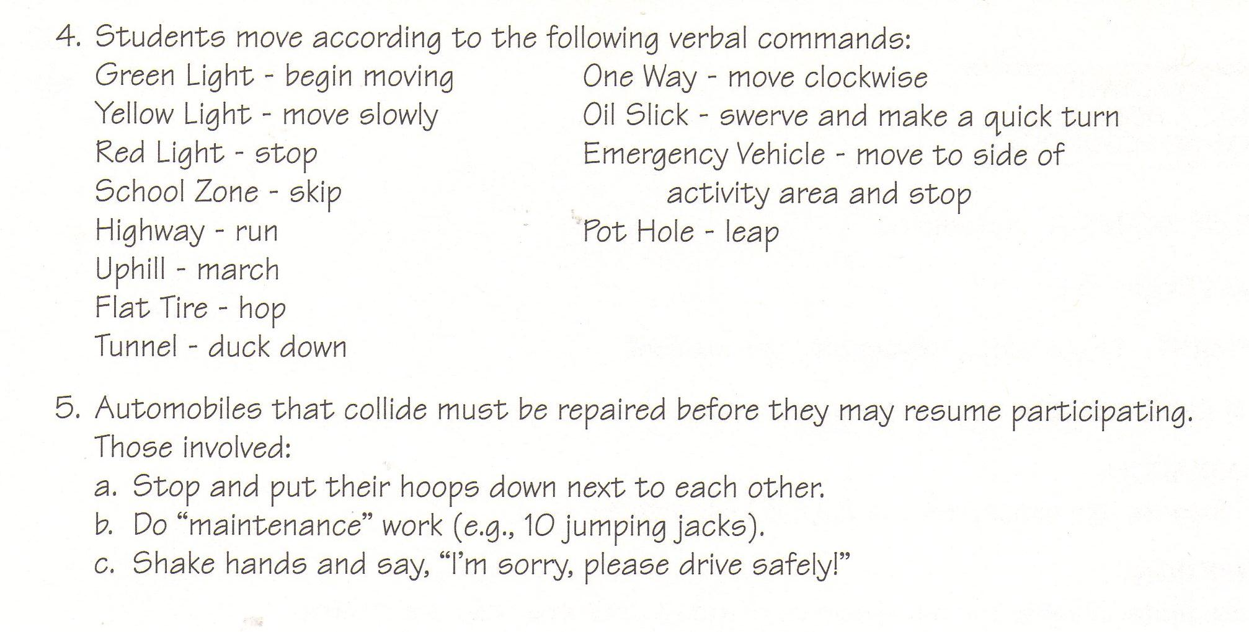
Hill Dill- using a large rectangular playing field, one player is chosen as the “it”. All other students stand on the sideline until the “it” says “hill dill come over the hill, I’ll catch you if you’re standing still”. Players attempt to run to the other side while the “it” tries to tag them with a soft touch tag. Tagged players then join the “it” in the middle and help tag for the next round. Repeat until most players are tagged. (may use flag belts as a means of tagging or a two finger tag).
Shadow Tag- all students are it. A tag occurs when a student steps on the shadow of another. All keep playing and trying to tag everyone’s shadow.
Relay Races- Using cones, establish a start/finish line and a turnaround point. Divide into even teams (as even as possible). Should not be more than four on a team. All team members can be together in a line or half at the start line and half at the turnaround point. Students must wait for a tag or hand-off before they go.
*animal walks *locomotor skills (walk, jog, skip, gallop, run, side slide, jump (2 feet), hop (one foot)
*soccer dribble *basketball dribble *baton hand off *jump rope
*hula hoop (around a body part or make it roll across the ground by pushing it along the top edge and repeat)
*move inside a hoop with a partner
*whole team holding outside of hoop and travel together
*Kangaroo - ball between knees and jump to travel
*Train- all students in order holding onto a long rope and travel down and back
*Three legged relay- use a potato sack for partners to put one foot each inside
*Inside a hula hoop two people have to dribble a soccer ball down and back alternating turns touching the ball with their feet.
Back to Back Tag Players: Entire Class Equipment: None
Chose 5 students to be it holding a soft fleece ball. When any two players stand back to back, they are safe. As soon as back to back players are safe, they will count to five then separate to find new partners.
(Any player tagged becomes IT and the game continues).
Quick Feet- In partners with chalk, create a 5 element pattern (die face). Write numbers, shapes, color names, etc. One partner will be the caller for the other student to as quick as they can react and move to that next item.
These games are more challenging and require a higher skill level for success. (4th and 5th grades)
Pickle Groups of 3 Equipment: 2 bases and 1 ball for each group
Two bases are placed on the field approximately 10 feet apart with a base runner between them and baseman at each base. The base runner attempts to successfully reach either base while the basemen throw the ball to each other in an attempt to tag the runner. If successful, the runner scores a point. If unsuccessful, he/she trades places with the player who tagged him/her (a good time to dart to a base is when on of the basemen overthrows his/her partner.) More than one point can be scored if the runner continues to go from base to base without being tagged. The runner must run on the second throw.
**Offense- the team with a ball/object trying to score by getting their ball/object to a certain goal area. **Defense- the team trying to stop the goal from happening by guarding the other team and trying to get the ball/object. Ex. Basketball/Soccer- offense players dribble to control the ball and try to work with their team to move the ball down the court/field to shoot in a goal. Defense is trying to take the ball away without touching the other team.
3 Pass Game- games of 2 vs 2 or 3 vs 3. Offensive team members try to get three catches in a row to score a point. The player that has the ball may only move two steps and then must use a pivot only. The defense tries to intercept and get in the way so the pass cannot be completed. If the offense drops the ball, it immediately goes to the other team. A ball may not be hit out of someone’s hands. Variation: Add 2 hula hoops as goals. Once the 3 catches have been made then the offense tries to shoot into either hoop. More than 3 passes can be used if needed.
Soccer- 3 vs 1 keep away, 1 ball. Offense is in a triangle, defender is in the middle. Offense is trying to pass the ball without the defender stealing it. When person in the middle touches/gets the ball they go out to the corner of the person who made the error. (Object is not to kick the ball really hard, control).
1 vs 1 keep away, 1 ball. Offense dribbles/controls the ball and attempts to “shield” the ball (use their body to protect the ball).
Soccer Duel- 1 vs 1 with two cones placed 30 to 50 feet apart. The person with the ball tries to dribble and fake out the defender to touch their cone with the ball. When the defender steals the ball they try to take the ball to hit their cone. (no boundaries)
Soccer Doubles- two versus two just like duel above.
Soccer Square Pin Knock Down- create a large square (20 x 20). 4 players are outside the square (offense) and 4 players inside the square defending 4 targets that the offense is trying to knock over by kicking the ball. You may need to put the targets inside a hula hoop that the defense cannot go in. Defense will kick the balls out of the square back to the offense. When two pins have been knocked down trade offense and defense.

DECEMBER 2015 – JANUARY 2016
Themes: Mind, Muscle and Healthy Hearts
Start each recess with 5 min. of walking/jogging. Allow those that want to tally more laps keep going. Have a student helper tally laps. As a class when you have gotten to 100 miles during December and January, write down your name and total miles on an index card and place in Mrs. Sluder’s mailbox. Prizes!
Soccer- (modified games)
Circle Soccer- two teams form semi-circles and then attach to form a big circle. The object is to pass the ball out of the circle between the feet of the opponent’s side of the circle. Ball must roll on the ground for a score to count (kick the middle of the ball, not under). Player should stop the ball with a trap before kicking it away. Students may pass to their teammates. No hands or arms can be used.
Shoot and Score- groups of 3 with one soccer ball. Two students face each other with the third in the middle. The outside players try to kick the ball on the ground through the legs of the center player. Center player stands in a wide straddle. Variation: kick with not favorite foot, partner in the middle scores with a miss, kicker scores with a make, play 2 vs 1 keep away.
Marbles- With a partner, each student has a ball. Player #1 tries to kick their ball to hit player #2’s ball (3 chances). Then player #2 takes their turn trying to kick their ball to hit player #1’s ball. Point awarded for hitting the other persons ball.
Four Ball Shootout- two goals, one goalie per team, four balls. Divide class into two “even” teams **adults choose teams** (number off 1’s and 2’s for example, A, B, C, D and then have A’s and C’s together and B’s and D’s be together). After a score, the person who made the score takes the ball back to mid-field for it to be put in play again.
Soccer Pirates- inside coned area have ½ to 2/3 of the class foot dribbling a ball (treasure). The others are the pirates who want to steal the treasure. When someone’s treasure is stolen they become the pirate trying to steal another treasure. When the whistle blows if you have control of a ball you get a point.
Soccer Tunnel Tag- All players have their own ball. Several players are the taggers who hold the ball In their hands. Everyone is dribbling and trying to avoid having their ball hit by a tagger throwing the ball. When tagged (ball begin hit) the tagged player must pick up their ball and hold it over their head, standing with feet wide (straddle). Those still in the game try to unfreeze players by dribbling the ball between their legs.
On days that it is too cold/rainy to go out, please refer to Mrs. Sluder’s web page for indoor activity ideas and internet based movement options. annesluderpe.weebly.com
You may also request to be included in Mrs. Sluder’s google drive files filled with recess indoor and outdoor activities. E-mail Mrs. Sluder anne.sluder@cms.k12.nc.us
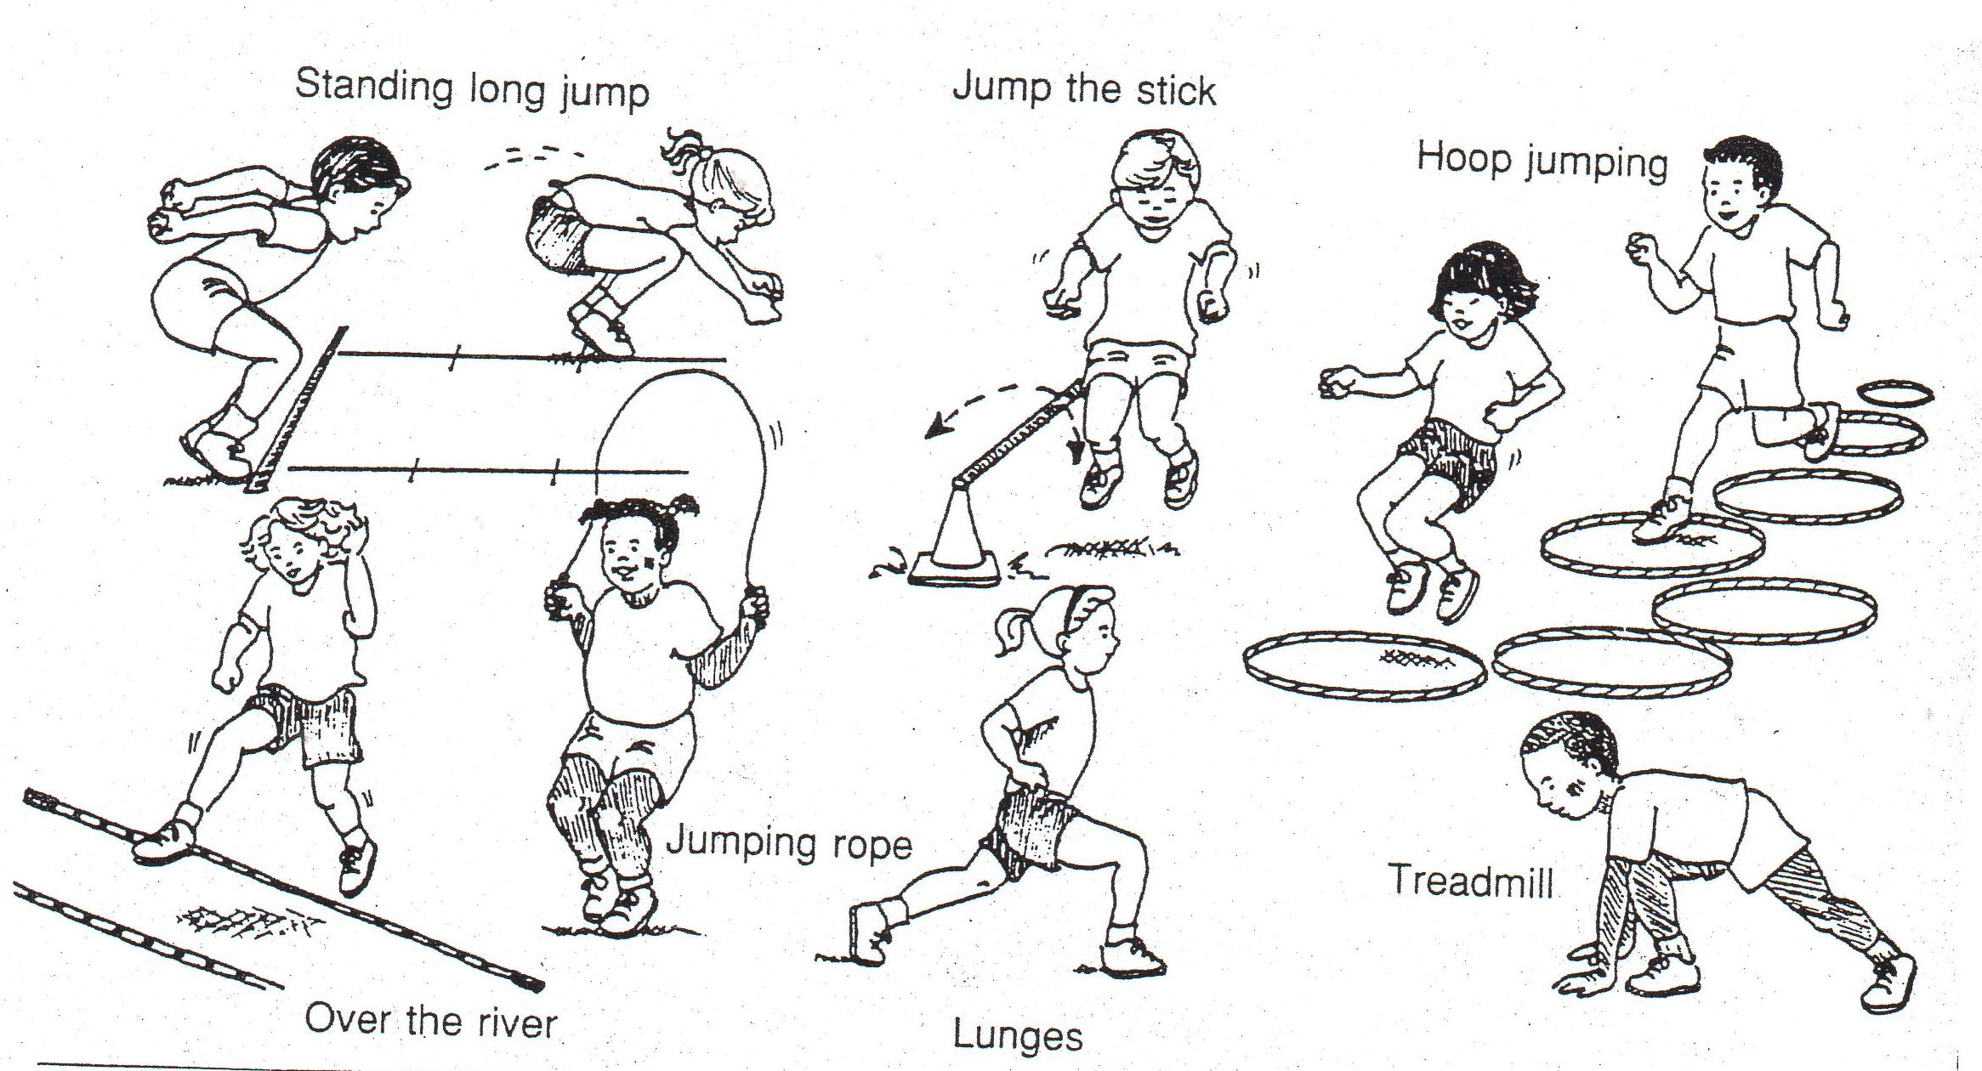
Exhale- Half of class on start line side by side, other half of class behind them. Group #1 takes a deep breath and on “Go” runs forward yelling “AAAAHHHHHH”. Each person freezes right where they run out of breath. Then have group #2 go. Who can go the furthest on one giant breath?
Around the Bases Relay- Place half the class behind second base and the other half behind home plate. On the “GO” signal, lead runners run the bases counterclockwise touching all the bases before tagging the next person in line. Which team can complete the rotation first?
Toss/Catch Activities- (various balls/beanbags) Easiest to most challenging
Toss/catch to self
1. Toss and catch from these levels - low, medium and high
2. Add a trick before the catch (clap, spin)
3. Toss from one hand and catch with the other
4. Toss with a different body part and try to catch
5. Try tossing using two objects.
Toss/Catch with partner (right hand throwers step with left foot, left hand throwers step with right foot forward)
1. Partners stand facing and hand the ball back and forth to their partner. Take one step backward, make 4 catches in a row from close range with an underhand toss. Take one step backward and try again for 4 in a row. A good distance is one that partners will catch 8 out of 10 throws.
2. Underhand toss to low, medium and high level for partner to catch.
3. Underhand toss so partner has to take a step right, left , backward or forward to make the catch.
3. When the catch is “easy” for a group add the challenge of a math problem. Partner with the ball calls out 4 – 1 and then tosses the ball. The catcher tries to say 3 before the catch is made.
4. Partners can spell their vocabulary words alternating as they catch. Example: SOCCER
player #1: S #2: O #1 C #2 C #1 E #2 R
5. Overhand throwing with partner (football, fleece ball, small playground ball, squishy ball)
6. Deck Ring/Frisbee toss with partner
7. Have one partner throwing from a spot while the other partner is moving (lead pass) football, Frisbee, other object.
Thrower must send it out in front of the mover so they don’t have to stop to make the catch.
8. Team Juggle- groups of 5 or more, bean bag or ball. Students will create a star pattern to throw in order from the 1st player up to the 5th. (thus cannot pass to someone beside you or someone who has already caught the ball.) When the order has been determined students will practice with one ball tossing it in order. When successful, the teacher will add a second ball to the group juggle. Make sure the next person is ready before the toss. Count successful catches in a row for a team score.
FEBRUARY – MARCH 2016
Themes: Sending and Receiving and ON and Off Balance
Start with 7 min. of walking/jogging/running. Children are preparing for the Pacer Run Test in April.
Rugby (toss catch with partner) must be a lateral pass (underhand motion with straight arms) borrow from Sluder
Field Ball Split class into small team games 2vs 2 or 3vs 3
Equipment: 1 ball (ball, Frisbee, rugby ball) per game, 4 cones or milk jugs, hula hoops to mark the playing area
The object of the game is to pass the ball or Frisbee down the field across the other team’s goal line. Throwing it can only advance the ball or Frisbee. Players may not run with the ball/frisbee. If the ball/frisbee touches the ground, or is intercepted, the other team gets the ball/frisbee at that spot. The game begins with a throw off. One team throws the ball/frisbee from behind the opponents’ goal line. Opponents move down the field to catch the ball.
Frisbee Golf Players: Groups of 4
Equipment: Carpet squares for tees, hula hoops/ropes/boxes for holes. Set up 4 holes on the playground. Allow 4 players to play together. Give each a different color Frisbee. Each player will throw his/her Frisbee from the first tee (carpet square). Count each throw the individual player makes in order to reach each hole. The player with the lowest score after completing all holes, wins.
Create your own games- have students come up with their own games! Create rules, scoring system and how to play directions to then share with Mrs. Sluder to publish to the Sterling shared google drive folder.
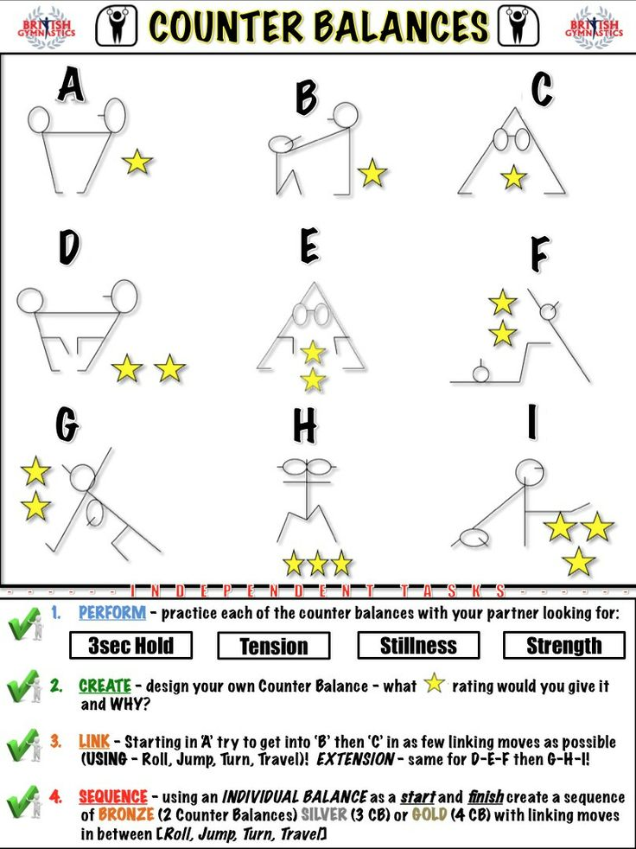
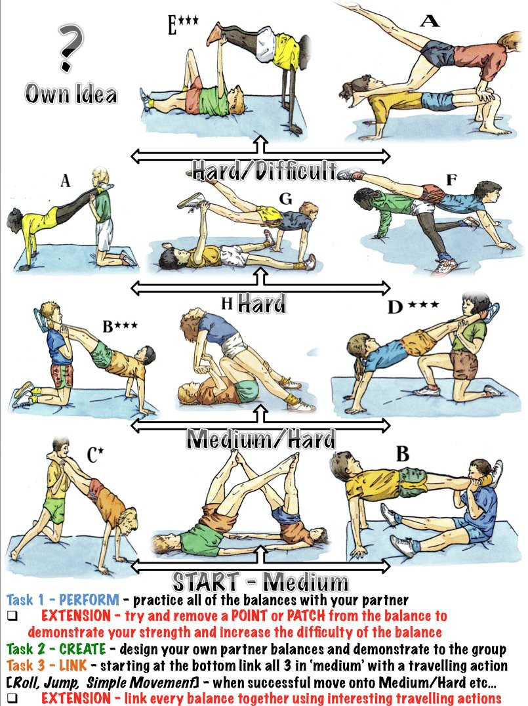
APRIL- MAY - JUNE 2016
Themes: Muscle Up, Striking (you will need to request equipment from Mrs. Sluder)
Paddle ball (volley # in a row)
Volleyball (pass/set challenge)
Softball/Baseball Batting
Deck Tennis Players: 4 - 6 per team Equipment: 1 deck tennis ring and 1 net per game
Formation is the same as for volleyball. Play begins with the server throwing the ring over the net to the opponents (receivers). The ring remains in play - thrown back and forth across then net - until there is a miss. Three players may play the ring before throwing it back over the net. If the receiving team misses, the serving team scores one point, and the next play begins with the same server. If the serving team misses it loses the serve, no point is scored for either team, and the next play begins with the opponents as the serving team. Each time a team wins a point, the same server serves for the next play. Each time a team wins the serve, players on that team rotate one position clockwise and remain in the new position until the serve is lost and won back again. The ring must be thrown with the same hand that caught it- thumb side up with arm swinging across the body. If the ring is thrown with the right hand, the right side is toward the net. The first team scoring 15 points with a 2-point advantage wins. Misses include touch the ring with both hands or holding it against the body, changing the ring from one hand to another, throwing with hand and arm in wrong position.
Newcomb Players: 2 - 6 per team Equipment: 1 volleyball per court
Played the same as volleyball trying to have 3 touches on each side to get the ball over. Except:
1) The server serves the ball over the net to begin play (overhand or underhand)
2) The receiving player catches the ball then throws it to a teammate to continue play. 3 touches on each side and then send it over with a toss. Points are scored when the ball lands on the ground or out of bounds. A point is scored at each dead ball. Rotate Clockwise to get a new server.

Parachute Activities Players: Whole Class
Equipment: 1 parachute, various balls Using an overhand grip (knuckles up):
Elevator- Parachute starts at the feet and when the teacher says “elevator up”, students lift the parachute when teacher says “elevator down” students pull the parachute down. Repeat several times.
Blooming Flower- Children pull the parachute down and then kneel on the outside of the parachute; put hands on parachute; then lean in and out to represent blooming.
Mushroom- Lift the parachute overhead, arms extended upward. Take 3 or 4 steps toward the center and freeze, allowing the parachute to balloon into a mushroom shape. Walk out backwards.
Shaking-Lifting- Holding the parachute waist high, start a shaking or fluttering motion. On signal, lift the parachute overhead as high and as forcefully as possible, but don’t let go. Return to shaking at waist.
Igloo- After making a mushroom change one hand at a time to turn so that everyone’s back is toward the center. Step backward toward the center. Quickly lie face down and pull the parachute over your head.
Popcorn- Place different types of ball on the parachute. Shake the parachute until the balls all bounce off it and onto the floor. Variation: 2 teams- one team holding half of the parachute, the other team holding the other half. Try to shake the balls off your opponent’s half of the parachute.
Circus Tent- When making a dome, students take a couple steps inward and bring the parachute down behind them and sit on the edge of the chute.
Merry-Go-Round- Students grab the parachute with one hand (all students the same hand) and move in a circle; they can move by various locomotor movements such as sliding, galloping, walking, jogging, etc.
Chute Crawl- Most of the class will be shaking the parachute on the ground; have 4 - 6 students crawl on the moon.

